**Chapter 22 Programming Assignment**

By Reno Redaja

**Project 22.1**

Write a program that prompts the user to enter a string and displays the maximum increasingly ordered subsequence of characters. Here are a few example runs:

Enter a string: hello world

Maximum increasingly ordered subsequence is elow

Enter a string: windward

Maximum increasingly ordered subsequence is inw

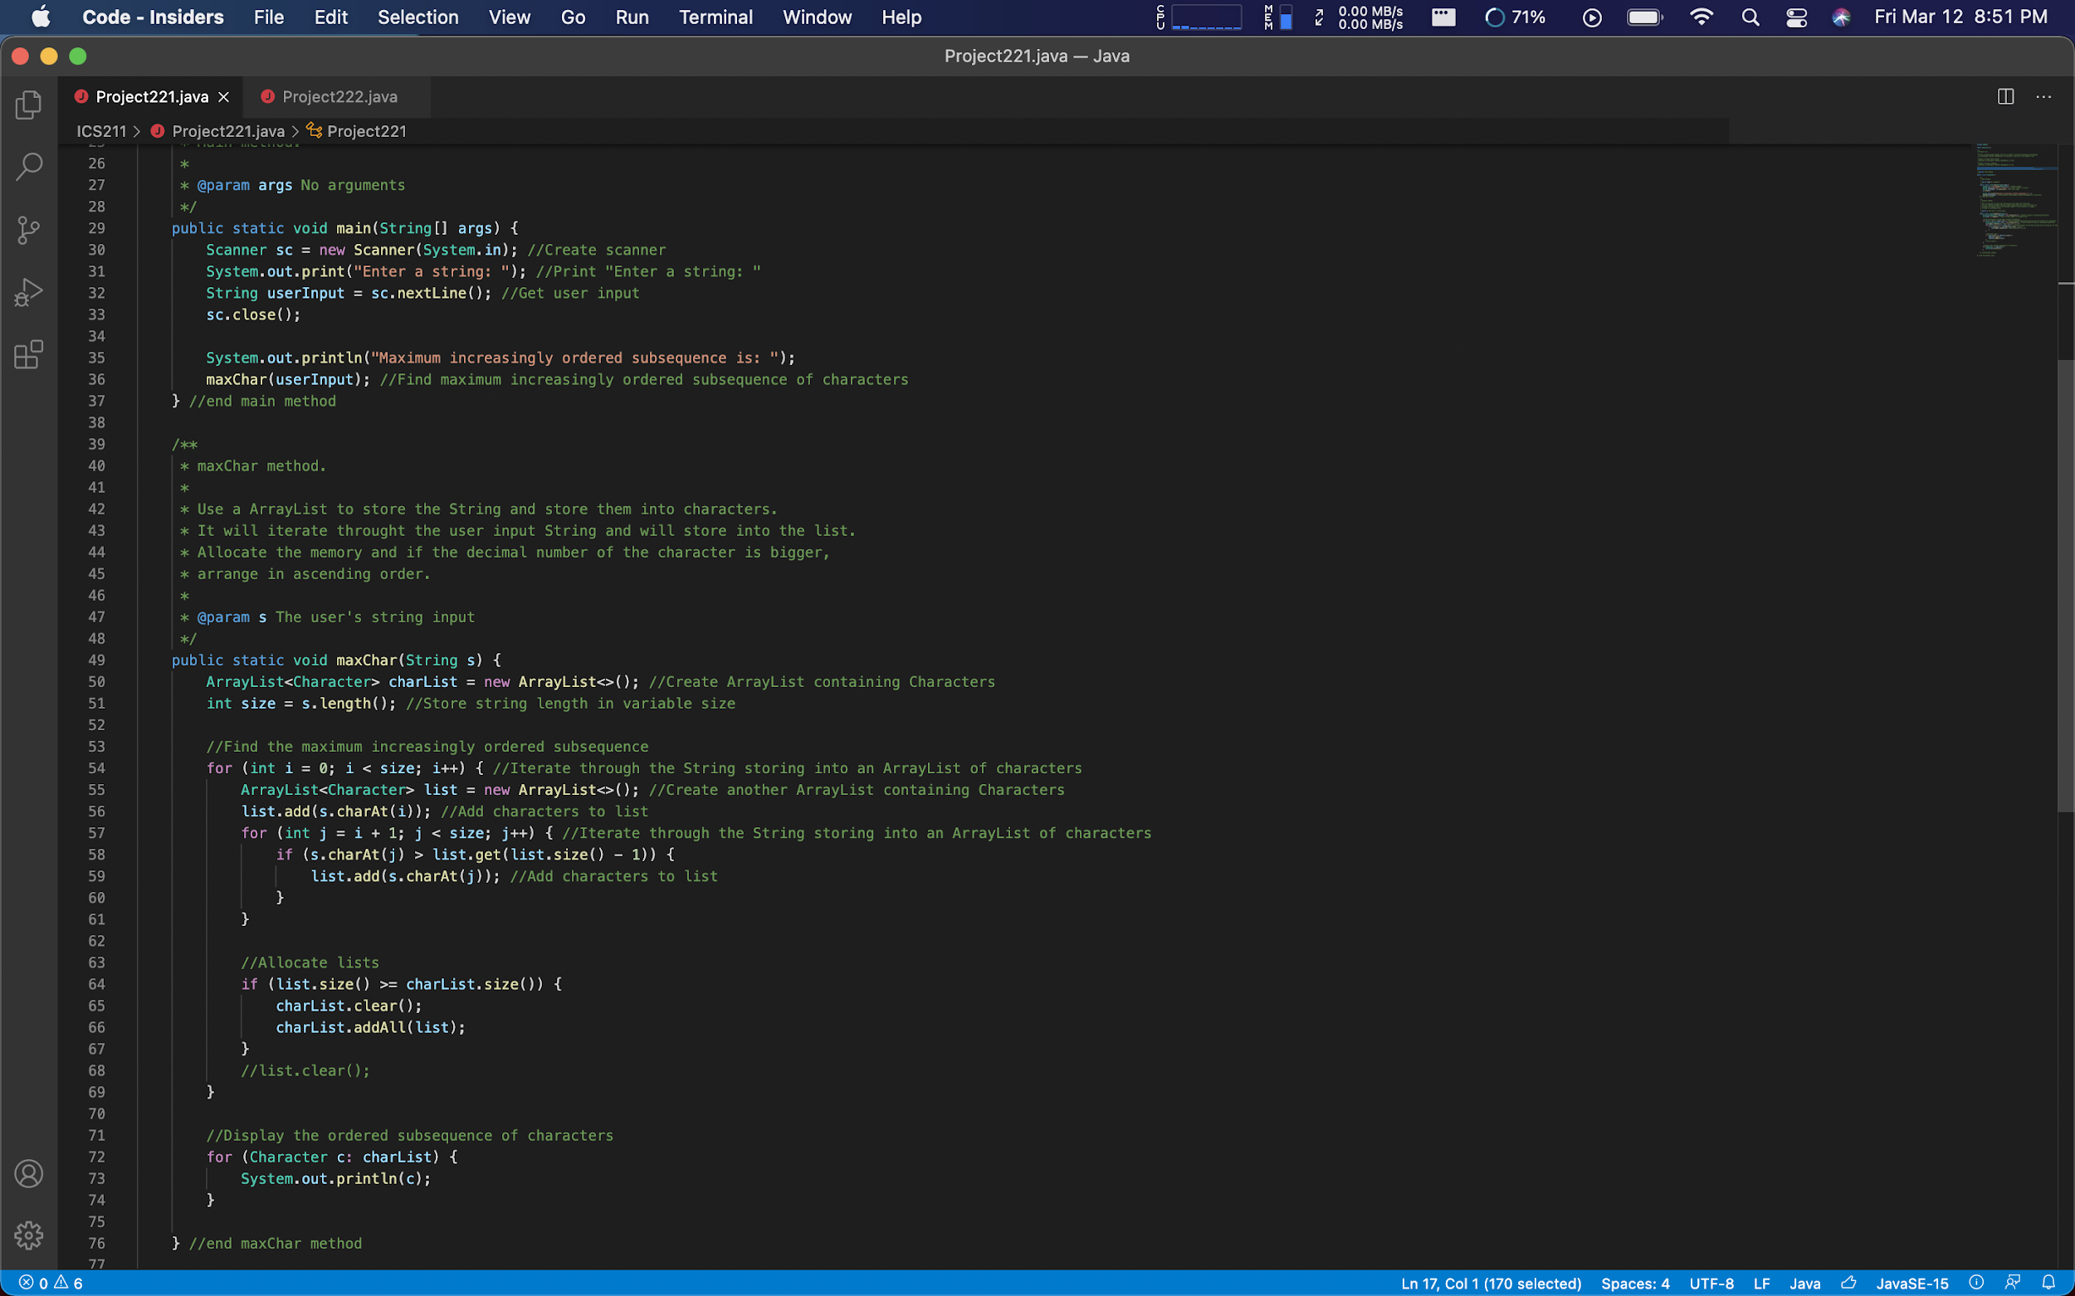

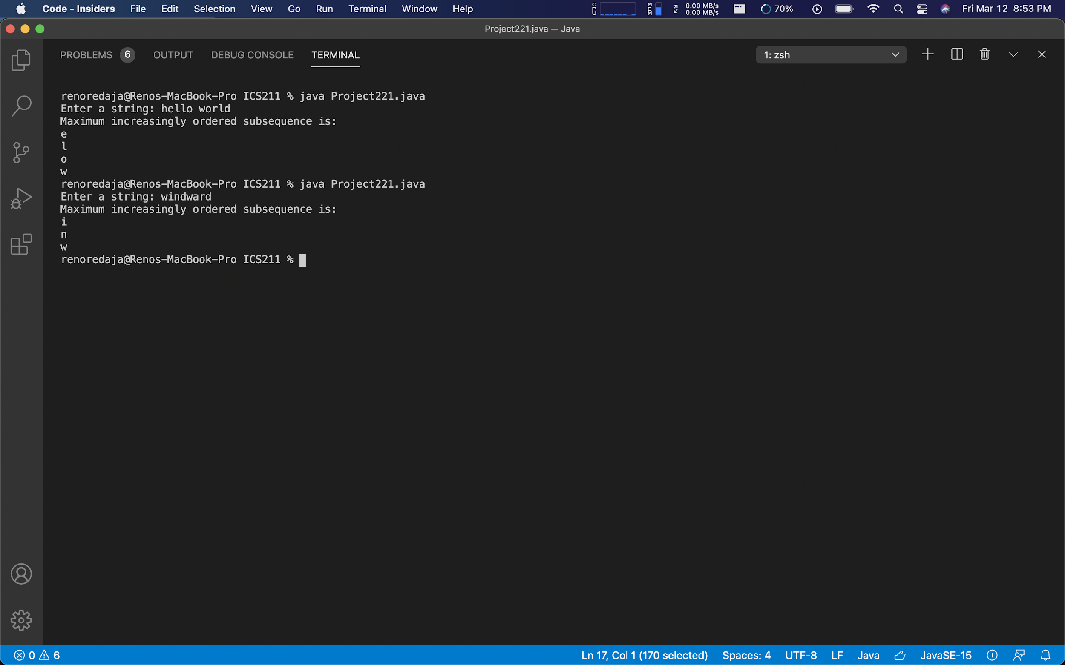

My program meets Project 21.1 requirements because it answers the prompt correctly. Within my program I have designed it to store the user String input in an ArrayList which holds Characters. It searches the ArrayList of Characters for the maximum number ordered sequence and displays it.

**Project 22.2**

Write an O(n) program that prompts the user to enter a sequence of integers ending with 0, and finds the longest subsequence with the same number. Here are a few example runs:

Enter a series of numbers ending with 0:

**5 9 2 3 3 3 3 6 1 9 0**

The longest same number sequence starts at index 3 with 4 values of 3

Enter a series of numbers ending with 0:

**12 7 2 9 17 2 9 9 8 22 95 0**

The longest same number sequence starts at index 6 with 2 values of 9

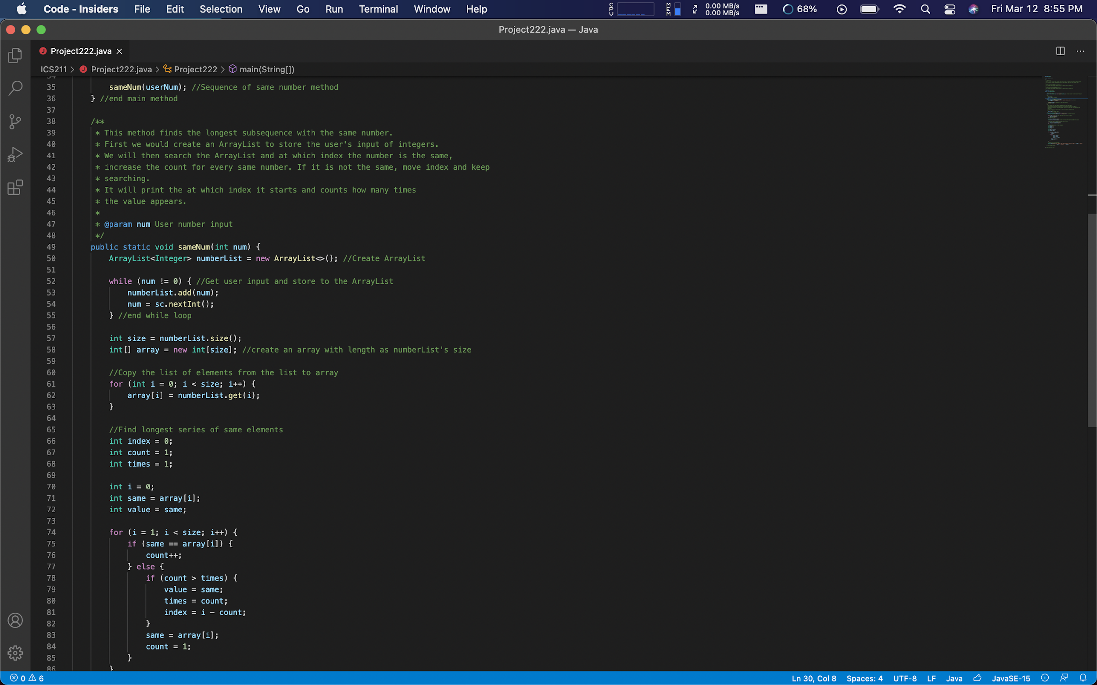

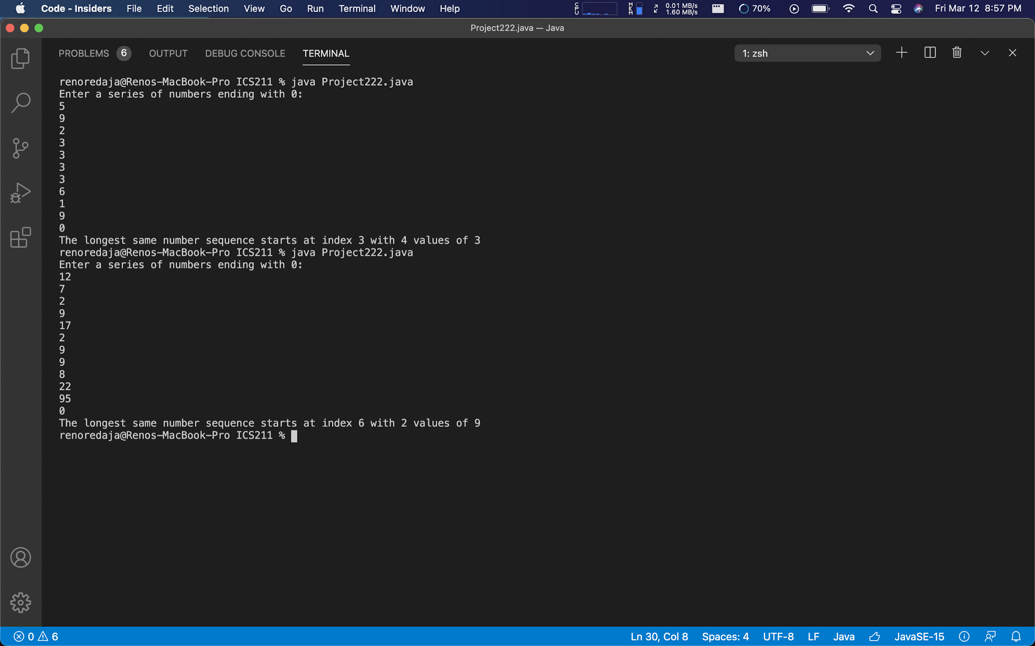

My program meets Project 21.2 requirements because it answers the prompt correctly. Within my program I have designed it to take in user input entering a series of numbers then ending with 0. I have created an ArrayList that stores Integers from the user. It then searches the ArrayList for the longest series of the same elements. It prints out at what index it starts at with how many times it is shown and what value it is.